Unit 11 Assignment Instructions – CIS164 
For the Unit 11 Assignment we will be focused on being able to identify errors within our scripts and then being able to act on them appropriately.
Please make sure to fully read each question to ensure that you answer each question per the requirement. Also, please ensure that all responses are in complete sentences, free of spelling and grammatical errors.
*Unit 11 Grading Rubric (45 Points):
Assignment Requirements | Maximum Points | Points Earned
1. Error Checking – 1 | 0-30 Points
2. Error Checking – 2 | 0-15 Points
Points Deducted for Spelling or Grammatical Errors
Total (Sum of All Points)
*Directions for Submitting Your Assignment:
Complete your assignment ensuring all questions are answered based on the assignment requirements. When the Unit 11 assignment is complete, please save your file in the following format, “Lastname-Unit#.doc” (Example: Smith-Unit11.doc). You may also utilize a Word Processing software such as LibreOffice for assignment completion. In this case the assignment may be saved in .odt format, (Example: Smith-Unit11.odt). Then when ready submit your file to the “CIS 164 – Unit 11 Submit Assignment” activity for grading.

1. Error Checking - 1
- Start the PyCharm IDE. Select “File->New Project” on the next screen, then under “Location” change the word “untitled” to “Unit11”. Then click the “Create” button.

- Highlight your project “Unit11” then right click. When you right click a menu will appear, from this menu select New->Python File. Then a dialog box will appear, in the “Name” field of the dialog box type “Unit11ErrorCheck1.py”.

- Within your “Unit11ErrorCheck1.py” file you will be creating a program that will allow a user to enter a golfer’s name and their golf score for as many golfers as needed, with its output being written to a file named ‘golf.txt’.

- For your script, you must error check the golf score (it must be an integer)! If the golf score is not an integer you will need to Raise an Exception to state that the value is not an integer.

- The following is an example of what your ‘golf.txt’ should look like:

Tiger Woods
72
Arnold Palmer
68

- For your script, you will need to provide a screenshot showing your completed script run, and you will also need to submit it in a text file, along with this document.
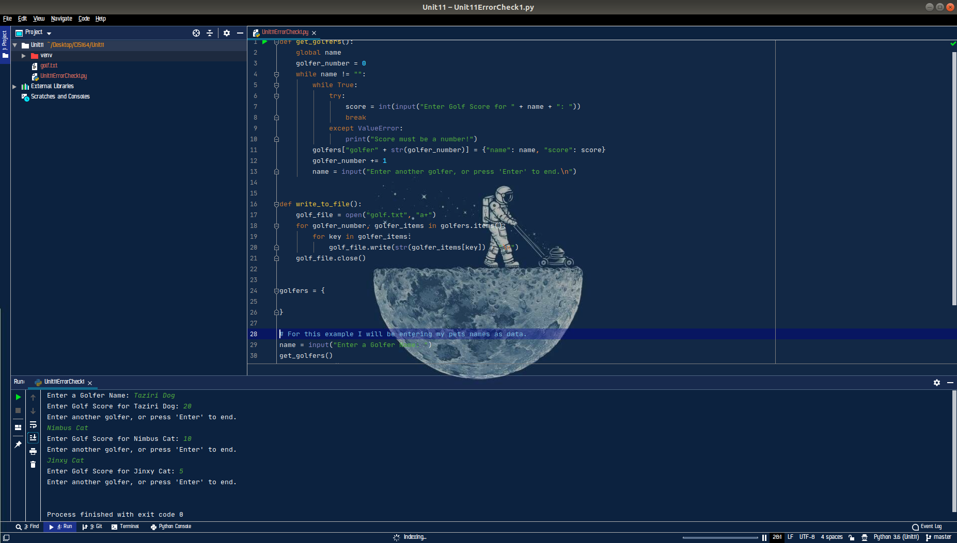
Unit11ErrorCheck1 Script
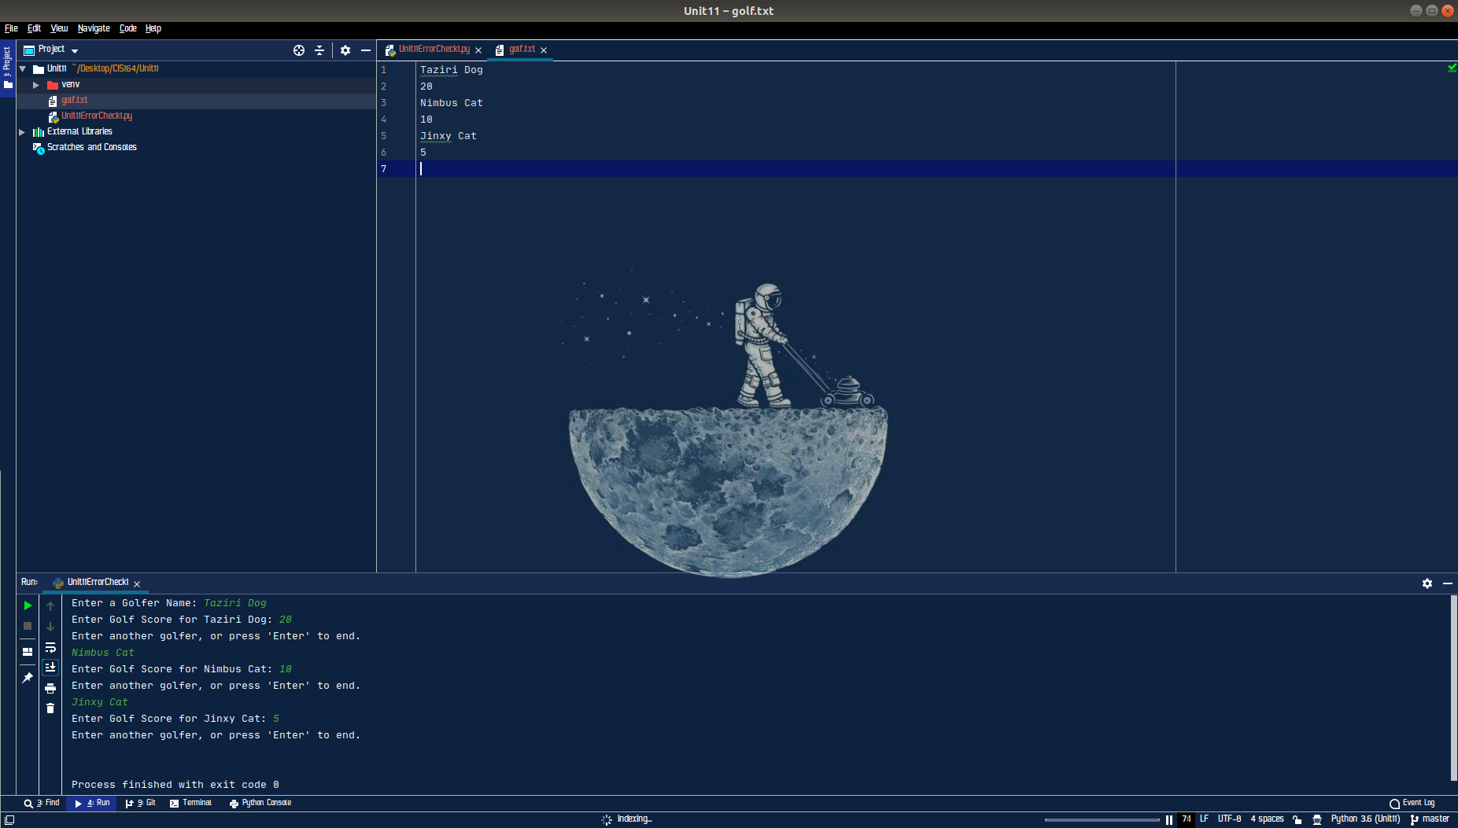
Text Output

2. Error Checking - 2
- Highlight your project “Unit11” then right click. When you right click a menu will appear, from this menu select New->Python File. Then a dialog box will appear, in the “Name” field of the dialog box type “Unit11ErrorCheck2.py”.

- Within your “Unit11ErrorCheck2.py” you can copy your script created for the previous task. However, this time you need to enable the logging module to log messages on your screen as your program runs. You need to have at a minimum one logging debug statement at the start of your script, one at the end, and one in the middle of your script.

- For your script, you will need to provide a screenshot showing your completed script run, and you will also need to submit it in a text file, along with this document.

